[**Emergency department triage prediction of clinical outcomes using machine learning models**](https://www.ncbi.nlm.nih.gov/pmc/articles/PMC6387562/)

**Problem Statement:**

Development of emergency department (ED) triage systems that accurately differentiate and prioritize critically ill from stable patients remains challenging. We used machine learning models to predict clinical outcomes, and then compared their performance with that of a conventional approach—the Emergency Severity Index (ESI).

**Target Label:**

The target label would be whether a patient will require critical care or not.

**Features Selected:**

1. Demographics
2. triage vital signs
3. chief complaints
4. comorbidities

However, they haven’t specified which features exactly.

**The ML Models: A comparison between 4 different models:**

In this paper, the authors use 4 different models and compare their results. These models are:

1. Lasso regression
2. Random forest
3. Gradient boosted decision tree
4. Deep neural network

In order to evaluate each of the 4 models, the authors decided they will use the Emergency Severity Index (ESI) as a baseline model. The ESI can have a value from 1 to 5, where 1 and 2 are considered critical and 3-5 are non-critical.

**Results:**

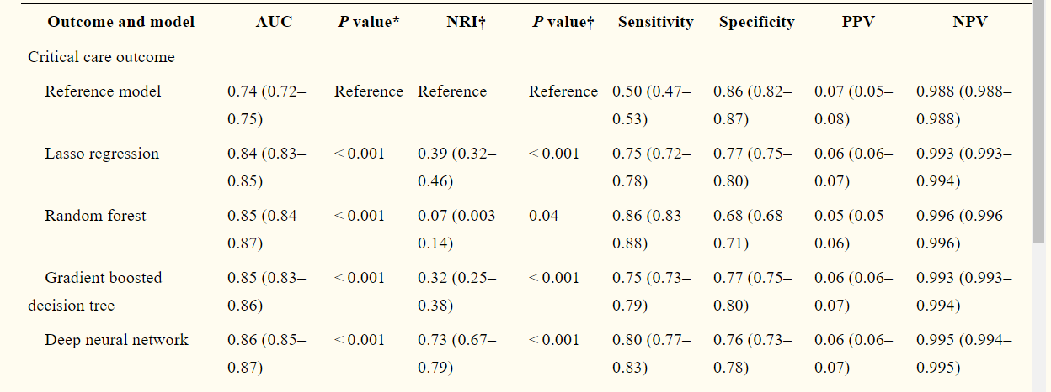

It can be seen that all 4 models outperformed the baseline ESI model. Moreover, it seems like the deep neural network model was the best out of all 4.